IEE/12/758/SI2.644752
D 3.1: Audit Guide
Annex I: Audit Report template
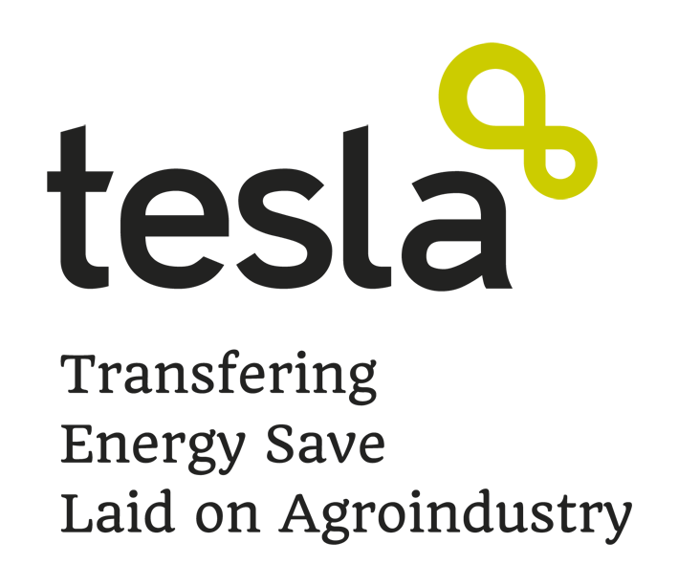
Author: Irene Cerezo
(Spanish Co-ops)
Update version:
October 2013

Authors:
Spanish Co-ops (Cooperativas agro-alimentarias de España)

About this report
This report has been developed in the framework of the TESLA project (Intelligent Energy Europe) and has been founded by the European Commission.

Copyright
This report can be copied and distributed always including notes of copyright. Teachers, trainers and any other user must always quote the authors, the TESLA project and the Intelligent Energy Europe Program.

“The sole responsibility for the content of this guide lies with the authors. It does not necessarily reflect the opinion of the European Union. Neither the EACI nor the European Commission are responsible for any use that may be made of the information contained therein”.

INDEX
1. Executive summary (2 pages) 4
1.1. Ranking of energy efficiency improvement opportunities. 4
1.2. Suggested program for implementing the measures 4
2. Background (5-7 pages, not counting with the pictures) 5
2.1. Context of energy audit 5
2.2. Auditing methodology 5
2.3. Auditor’s data 6
2.4. Cooperative’s data 6
2.5. Description of cooperative 7
3. Energy Audit (10-15 pages) 8
3.1. Analysis of energy consumption 8
3.2. Performance indicators 10
3.3. Identification of inefficiencies regarding energy consumption 11
3.4. Criteria for ranking the energy efficiency improvement measures 11
4. Energy efficiency improvements opportunities (2-3 pages PER MEASURE, not counting with the pictures) 13
4.1. Measure 1: 13
5. Conclusions of the audit (1-2 pages) 15
6. References (1 page) 16

Executive summary (2 pages)
Summarize briefly the main information of this report.

Ranking of energy efficiency improvement opportunities.
In this section should be explained the improvement measures proposed in this audit report, and the reasons why they are suggested.

Suggested program for implementing the measures
In this section should be explained the reasons why the above mentioned measures are listed following a specific order of preference. In this sense, a program for implementing the proposed measures should be included.

Background (5-7 pages, not counting with the pictures)

Context of energy audit
This energy audit is defined in the context of the European Program INTELLIGENT ENERGY – EUROPE and in its TESLA project aimed at reducing energy consumption in the agro-industries of the following subsectors: olive oil mills, wineries, fruits and vegetables processing plants, and animal feed factories.
Taking into account the allocated budget for this TESLA project, the energy audits executed on it will be perfectly adjusted to cooperatives’ necessities and will be thoroughness enough to obtain results and improvement measures that will provide cooperatives with the perfect knowledge to take their decisions about energy improvements in their facilities.
The energy audit written in this report has been executed, as programmed in the TESLA project, in around 15 days, including 3 or 4 visits to the cooperative.
Finally, the boundaries of this energy audit were defined in the first conversations with the cooperative’s responsible personnel and were included only cooperative’s facilities, not outsourcing works and not transport out of the cooperative’s facilities.
Besides that, the auditor will define in detail the specific information about the scope of the audit in this specific cooperative (which facilities will excluded in this audit and the reasons why)

Auditing methodology
The audit methodology used for this audit report has been elaborated in the context of TESLA project, and it has been defined taking into account previous experiences of other projects dealing with energy audits in agro-food sector, or in other related sectors. Besides that, the methodology used for this energy audit includes knowledge of experts in the corresponding subsectors (olive oil mills, wineries, fruits and vegetables processing plants, and animal feed factories) coming from different Universities and Technological Centres from the four countries participating in TESLA project.
The main methodology of this energy audit is based on the information gathered from the cooperative, the measurements done by the grid analyzer and other devices, and the analysis of all this information. In this analysis, it is important to explain that some information was estimated (load factor, working time per machine, etc.), and some other information was measured by the grid analyzer following the instructions included in the Audit guide and its Annexes.
Finally, the result of this analysis has been the inefficiencies found, and the proposed improvement measures to solve these weak points, and include them in the fourth point of this report.
After this audit report, the most important step will be executed by the auditor with the cooperative’s responsible personnel: the presentation of this audit report and the meeting with the corresponding Key Actors to settle the most interesting improvement measures for the cooperative.

Auditor’s data
The person here indicated was in charge of executing the energy audit of this cooperative.
Auditor’s name and surname
Email
Organization to which the auditor belongs to
TESLA partner organization
Country

Cooperative’s data
The general data of the audited cooperative are:
Name of the cooperative
Location
Country
Sub-sector

Director/President of the cooperative | (person who signed the Commitment Letter)
Contact person in the cooperative (for the execution of this energy audit) | (person who helped the auditor in the energy audit execution)
Email and/or Telephone

Annual production (specify units)
Building surface
Working days per year
Working hours per day

Description of cooperative
Include brief description of the above mentioned data (facilities of the cooperative, its activity, average annual production, inventory of equipments, etc.) and a clear and concise, but complete, description of the process of the cooperative.
Pictures could be included in this point.

Energy Audit (10-15 pages)

Analysis of energy consumption
The information received from the cooperative and by means of the grid analyzer measurements is presented in the following paragraphs, explained from different points of view.

- Energy consumption per source (classifying as: electricity, liquid fuel, natural gas, and biomass)
Description of the consumed energy sources, their usages, and the percentage of each energy source within the total energy consumption of the cooperative.
Include a table with the data gathered about energy consumptions per source in the studied months.
Graphs from the “data report” Excel sheet of Annex-IV-Check list should be included.
In this point, it is desirable to include data gathered from 24 months (or minimum 12 months)

- Energy consumption during the year (mentioning the seasonality)
Description of the energy consumed thorough the year, explaining the reason of the different energy consumption in the different months (outside climate, peak of production, harvest, bottling, cooperative´s closure, etc.)
Include a table with the data gathered about energy consumptions thorough the year, in the studied months. A different table should be included per energy source.
Graphs from the “data report” Excel sheet of Annex-IV-Check list should be included.
In this point, it is desirable to include data gathered from 24 months (or minimum 12 months)

- Energy consumption during the hours of the day.
This point will be interesting in those cases where the activity during the night should be analyzed (to find hidden consumptions, for example), or when the start of the cooperative should be studied to look for solutions trying to spread out the start of the plant.

- Energy consumption per process (breakdown of processes)
Description of the processes following the breakdown of processes as indicated in Annex IV-Check list (specific for each subsector) in the “industrial process” Excel sheet. The process should also be explained specifying the energy source used and the kind of equipments included in each process. Besides, an explanation about which equipments energy consumption were estimated and which ones were measured should be included.
Include a table with the data obtained about energy consumed per process and per year. When necessary, a different table will be included per source of energy.
Graphs from the “data report” Excel sheet of Annex-IV-Check list should be included.
Include also a SANKEY’S DIAGRAM.

Performance indicators
(comparison of performance data with other cooperatives’ performance data)
Analysis the energy consumptions related to the annual production of the cooperative.
Include the following rates:
Process | Electricity consumption per production | Diesel consumption per production | Natural gas consumption per production | Biomass (specify which type of biomass) consumption per production
Process 1 | kWh/ton | l/ton
Process 2
…
TOTAL

OPTIONAL: After obtaining the values of these indicators from other cooperatives of the project belonging to the same sub-sector, an analysis about its differences will be included here. It can be done with cooperatives’ data from the same country or other countries, depending on the available results from other auditors at the moment of the Audit report execution.

Identification of inefficiencies regarding energy consumption
Following the analysis of the differences between the here audited cooperative and others, it will be easier to identify inefficiencies.
In this section will be included:
- List of identified inefficiencies.
- List of proposed improvement measures to correct each identified inefficiency.
- Energy analysis of the proposed measures (energy savings obtained by implementing it).

Criteria for ranking the energy efficiency improvement measures
Taking into account the energy analysis, in this section will be established the ranking of measures, from the most recommendable to the less important one.
Include a table with the following information about each measure:

Measure | Energy savings  (specify units) | Economic savings  (€) | Investment  (€) | Pay back  (years) | CO2 savings  (optional)
Measure 1
Measure 2
…

Energy efficiency improvements opportunities (2-3 pages PER MEASURE, not counting with the pictures)
Following the order obtained in the ranking of energy efficiency improvement measures, these measures will be explained in-depth in this section.
The information that must be included regarding each measure is:

Measure 1:
- The measure:
Explain the proposed measure. Some pictures may be included in this point.

- Energy savings calculations:
Assumptions in the savings’ calculation and its explanation, as well as justification of the accuracy of the obtained results (include the breakdown of the calculations made for the energy savings analysis).

- Measure’s implementation:
Include information about its implementation (installation, additional works that would be done, its additional costs, etc.)

- Economic savings:
Explanation about the economic analysis (include savings’ calculations, investment, source of the used data, etc.)

- Grants or subsidies:
Include additional information about applicable grants or subsidies for the implementation investment.

- Interactions:
Interaction with other proposed measures.

- Verification a posterior:
Measurements and verification methods that will be used to asses a posteriori the identified opportunities and advantages for this measure, as well as its energy savings really obtained.

Conclusions of the audit (1-2 pages)
General conclusions about the energy situation of the cooperative and especially about the proposed improvements will be included in this section.

References (1 page)
All the consulted documentation, web pages, commercial catalogues, etc. should be specified in this point.

