IEE/12/758/SI2.644752
D 3.2: Audit questionnaires (English)
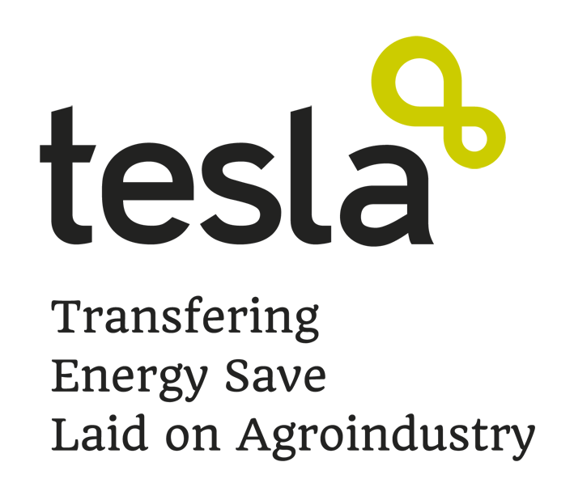
Author: Abel Ortego
(Centre of Research for Energy
Resources and Consumptions)

Update version:
November 2013

Authors:
Centre of Research for Energy Resources and Consumptions (CIRCE)

About this questionnaire
This questionnaire has been developed in the framework of the TESLA project (Intelligent Energy Europe) and has been founded by the European Commission.

Copyright
This questionnaire can be copied and distributed always including notes of copyright. Teachers, trainers, and any other user must always quote the authors, the TESLA project and the Intelligent Energy Europe Program.

“The sole responsibility for the content of this guide lies with the authors. It does not necessarily reflect the opinion of the European Union. Neither the EACI nor the European Commission are responsible for any use that may be made of the information contained therein”.

General data of the cooperative.
Cooperative: | Name:
Cooperative: | Address:
Cooperative: | Location:
TESLA subsector:  (tick one of the following) |  | Olive oil | Wine | Animal food | Fruits and vegetables
Manager: | Name and surname:
 | e-mail:
 | Telephone:
Maintenance technician: | Name and surname:

General data of the cooperative’s production, processes and facilities.
Month* | Production (ton or hl)**
ANNUAL:
*Please, in order to consider one productive year (one campaign) start filling in the grey boxes as follows:
- for olive oil mills: start in October.
- for wineries: star in August.
- for fruit and vegetable processing plants: in January.
- for animal feed factories: start in January.

**use ton for animal food, fruits or vegetables; and hl for olive oil or wine.

Facilities’ surface (m²): | Whole Cooperative:
Facilities’ surface (m²): | Industry:
Facilities’ surface (m²): | Offices:
Working days per year (approx.):
Working hours per year (approx.):
Cooperative’s year of foundation:
Current facilities’ year of built:
Reforms executed since current facilities’ year of built:
Select which of the following processes you have in your cooperative. (If you have more processes which are not included in the table below, please include them using the white cells).
Olive oil |  | Wine |  | Animal food |  | Fruits and vegetables
Process | tick if YES | Process | tick if YES | Process | tick if YES | Process | tick if YES
Raw material reception |  | Raw material reception |  | Raw material reception |  | Raw material reception
Grinding |  | Squeeze |  | Grinding |  | Post harvest processes (cleaning)
Churning and mixing |  | Pressing |  | Mixing |  | Drying
Horizontal centrifugation |  | Alcoholic fermentation |  | Granulating/ Pelleting |  | Handling and measuring
Vertical centrifugation |  | Compressed |  | Packaging |  | Packaging
Storage (decanting) |  | Malolactic fermentation |  | Storage |  | Cooling conservation before supply
Packaging/ Bottling |  | Filtered
 |  | Stabilization
 |  | Bottling

General data of the cooperative’s energy consumptions.
Sources of energy in the cooperative:
Petrol | Diesel |  | Coal |  | Gas |  | Biomass |  | Electricity
Energy annual consumptions (specify units):
Petrol: |  | Diesel: | Coal: | Gas: |  | Biomass: |  | Electricity (kWh):
Transformer power capacity (kVA):
(power capacity of the transformer connected to the grid, the power availability in the cooperative)
Power installed (kW):
(sum of power from each device, from the Industries’ Register or inventory, NOT power contracted)

Do you have a maintenance technician?
Do you have a maintenance plan?
Have the cooperative been energy audited before?

SEND THIS QUESTIONNAIRE TO xxxxx@xxxxx.xxx ATTACHING SOME IMAGES (in JPG format or similar) AND BASIC PLANES OF THE COOPERATIVE AND THEIR INSTALLATIONS (in PDF or DWG format)

